|  |  |
| --- | --- |
| **Nikon D850 (Body Only)**  Máy ảnh Nikon D850 (Body Only) | Chính Hãng  Nikon D850.2 Nikon D850.1 Nikon D850.3 Nikon D850.4 | **Featured information:**  * Sensor: Full-frame resolution: 45.7MP * ISO range: 64 - 25600 (expandable 32 - 102400) * Wireless connection: WiFi, bluetooth * LCD touch screen 3.2   **Price : 3000$**  **Specifications:**   * **Sensor Format:** Full-Frame (1x Crop Factor) * **Resolution:** 46.89 megapixels * **Size photo:** 8256 x 5504 * **Image Proportions:** 1:1, 3:2, 4:5 * **Sensor Type:** CMOS * **Image Format:** JPEG, Raw, TIFF * **Anti-Vibration:** Full * **Lens Mount:** Nikon F |

**Description:**

#### **45.7MP FullFrame BSI CMOS Sensor and EXPEED 5 Processor**

After 3 years since the launch of the D810, Nikon introduced the next generation to consumers around the world, the Nikon D850, at the end of August 2017. Nikon's D850 is expected to be the company's first FullFrame camera with the ability to optimize high image resolution, processing speed and performance. This is also the first FullFrame camera in the world capable of recording 8K resolution Timelapse videos.

#### **Durable, professional design of Nikon D850**

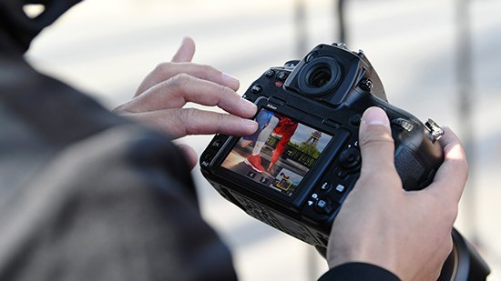

The device is also equipped with a multi-dimensional rotating touch screen, helping users easily compose in many difficult angles to create smooth and impressive films.